Recommended Books
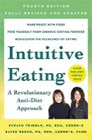
- Intuitive Eating 4th ed., 2020, by: Tribole & Resch
  - Make peace with food. Free yourself from chronic dieting forever. Rediscover the pleasures of eating.
  - https://amzn.to/34bY1hm
- The Intuitive Eating Workbook, 2017, By: Tribole & Resch
  - Do you use food to comfort yourself during stressful times? The Intuitive Eating Workbook offers a comprehensive, evidence-based program to help you develop a healthy relationship with food, pay attention to cues of hunger and satisfaction, and cultivate a profound connection with your mind and body.
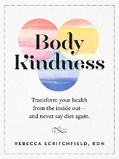
  - http://amzn.to/2kz6AgF
- Body Kindness, By: Scritchfield
  - This practical, inspirational, and visually lively book shows you the way to a sense of well-being attained by understanding how to love, connect, and care for yourself—and that includes your mind as well as your body.
  - http://amzn.to/2bwQfbA
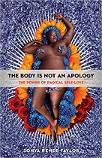
- The Body is Not An Apology, By: Taylor
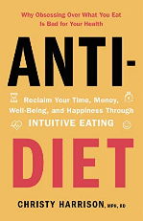
  - Humans are a varied and divergent bunch with all manner of beliefs, morals, and bodies. Systems of oppression thrive off our inability to make peace with difference and injure the relationship we have with our own bodies. The Body Is Not an Apology offers radical self-love as the balm to heal the wounds inflicted by these violent systems.
  - https://amzn.to/2EbXjqD
- Anti-Diet, By: Harrison
  - In Anti-Diet, Christy Harrison takes on diet culture and the multi-billion-dollar industries that profit from it, exposing all the ways it robs people of their time, money, health, and happiness.
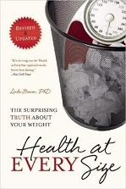
  - https://amzn.to/2NVVljh
- Health At Every Size: The Surprising Truth About Your Weight, By: Bacon
  - Fat isn’t the problem. Dieting is the problem. A society that rejects anyone whose body shape or size doesn’t match an impossible ideal is the problem. A medical establishment that equates “thin” with “healthy” is the problem. The solution? Health at Every Size.
  - http://amzn.to/MSevQo
- Body Respect: What Conventional Health Books Get Wrong, Leave Out, and Just Plain Fail to Understand about Weight, By: Bacon & Amphramor
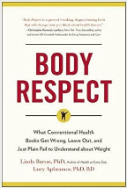
  - Weight loss is not the key to health, diet and exercise are not effective weight-loss strategies and fatness is not a death sentence. Dr. Linda Bacon and Dr. Lucy Aphramor’s Body Respect debunks common myths about weight, including the misconceptions that BMI can accurately measure health, that fatness necessarily leads to disease, and that dieting will improve health.
  - https://amzn.to/38lyplf
Intuitive eating podcasts

- Eat with Confidence with Stephanie Webb and Emily Fonnesbeck, RD
  - https://eatconfident.co/podcast
- Nutrition Matters with Paige Smathers, RDN
  - https://www.positive-nutrition.com/blog/categories/podcast
- Intuitive Bites with Kirsten Ackerman, MS, RD
  - https://podcasts.apple.com/us/podcast/intuitive-bites-podcast/id1383888050
- Nourishing Women with Victoria Myers, RDN
  - https://podcasts.apple.com/us/podcast/nourishing-women-podcast/id1273444999

Instagram Accounts to follow
- @embrace.mindbodywellness
- @enlightenedeating_dietitian
- @murraynutrition
- @truebeing_rd
- @jaimmykoroma
- @tiffanyima
- @jessicabuchanan_dietitian
- @binge.nutritionist
- @the.lovelybecoming
- @encourageingdietitian
- @hgoodrichrd
- @eatconfident.co
- @alignednutrition
- @no.food.rules
- @break.the.diet.pod
- @friendlynutrition
- @jenthedietitian
- @themindfuldietitian
- @caitsplate
- @dessert.without.guilt

Hashtags to follow
- #intuitiveeating
- #healthatanysize
- #healthateverysize
- #haes
- #intuitiveeatingofficial
- #selfcare
- #foodfreedom
- #allfoodsfit
- #bodypositivity
- #bodyacceptance
- #ditchthediet
- #joyfulmovement

Facebook Accounts and Support Groups
- Embrace Mind & Body Wellness
- Intuitive Eating Support Group
- Ditch the Diet - Intuitive Eating and Body Image Support
- Intuitive Eating and Body Love Support
- Intuitive Eating for Beginners: An Anti-Diet Support Group

